**M226B/IPT-6**

**MyPlattformer**

Documentation

Contents

Introduction 3

Used Tools 3

Applications 3

Used Sources 3

Used Sprites 3

User Stories 3

GUI 6

User manual 8

UI navigation 8

Main Menu 8

Setting 8

Levels 8

Game navigation 9

Movement 9

Combat 9

# Introduction

This project was developed in as a part of an IPT-6 project. The goal being practicing and consolidating experience in object orientated programming(OOP).

Ihave chosen to further improve my experience with the Unity-Gameengine and continue the development of my platforming game.

# Used Tools

## Applications

Visual Studio 2022  
Unity 2021.3.0f1  
GitHub  
[Wireframe.cc](https://wireframe.cc/)

## Used Sources

[Gamedev.tv](https://www.gamedev.tv/) ([Complete C# Unity Game Developer 2D Online Course](Complete%20C" \l " Unity Game Developer 2D Online Course))  
YouTube

## Used Sprites

All sprites used were included in the GameDev.tv course.

# User Stories

|  |  |  |  |  |  |
| --- | --- | --- | --- | --- | --- |
| Title | User Story | Acceptance Criteria | Priority | Expected time usage (h) | Status |
| Platforming mechanics | As a player, I want to be able to use common platforming mechanics like jumping, climbing and sprinting. | When player presses jumpkey, player jumps.  When player pressed upkey while standing on a ladder, player should climb on the ladder. The player should not fall down while standing on the ladder.  When player presses runningKey, player should run 50% faster. | 1 | 4 | Complete |
| Finishing and progressing in levels | As a player, I want to be able to complete a level and go to the next level. | When reaches the end of the level, the level should complete and go to the next level. | 1 | 0.5 | In Progress |
| Player mortality | As a player, I want to be able to die by objects like enemies or water and restart the level. | If the player touches objects like enemies, spikes or water all movement abilities should become locked, a blood particle effect should be played and the player should be knocked away. | 1 | 1 | Complete |
| Animation hanlding | As a player, I expect that animations changes depending on the current action. | Following animation should be implemented and changed when the player state changes:  Idling (doing nothing)  Running  Climbing  Dying | 1 | 2 | Completed |
| Camera transitions | As a player, I would appreciate of the camera behaved differently depending on my current action. | The camera should zoom out when running and zoom even more when climbing. The camera should zoom in after idling for 2 seconds. | 2 | 1.5 | Completed |
| Main menu | As a player, I want to have a basic main menu where I can start the game and exit the game. | When starting the game, or when the player presses the game, the main menu should appear, where the player has the option to “Continue/Play” the game or “Exit” it. | 2 | 2 | Not started |
| Ability to jump on ladders | As a player, I want to be able to jump on ladders. | The player is able to jump even when standing on the ladder. | 2 | 2 | Completed |
| Ability progression | As a player, I want to unlock new abilities like double jump as I progress further into game. | When the player completes a predefined level, new ability like extra jumps gets unlocked | 2 | 4 | Completed |
| Enemy mortality | As a player, I want to be able to kill enemies. | The player is able to kill enemies with rotating his swords. | 2 | 1 | In Progress |
| Projectiles | As a player, I expect that enemies shoot projectiles. | Enemies can shoot projectiles. | 3 | 3 | Not started |
| Reflecting of projectiles | As a player, I want to be able to reflect incoming projectiles. | The player can reflect projectiles with his swords. | 3 | 2 | Not started |
| Projectiles kills players and enemies | As a player, I expect that projectiles kill me or any enemies on contact. | The player or an enemies instantly gets killed if it gets in contact with an projectile. | 3 | 1.5 | In Progress |
| Progress saving | As a player, I would appreciate if my current progress would be saved and loaded when I open the game again. | The player’s current progress gets saved in an .txt file. | 3 | 2 | Not started |
| Level selector | As a player, I want to be able to open a level selector in the main menu and select levels. | The player can access the level selector via the main menu and select individual levels. | 3 | 2.5 | Not started |
| Volume setting | As a player, I want to be able to change the volume in the main menu. | The play is able to access audio setting via the main menu and change the volume. | 4 | 1.5 | Not started |
| graphic setting | As a player, I want to be able to change the resolution in the main menu. | The play is able to access graphic setting via the main menu and change the resolution. | 4 | 1.5 | Not started |

# GUI

Ein Bild, das Tisch enthält.

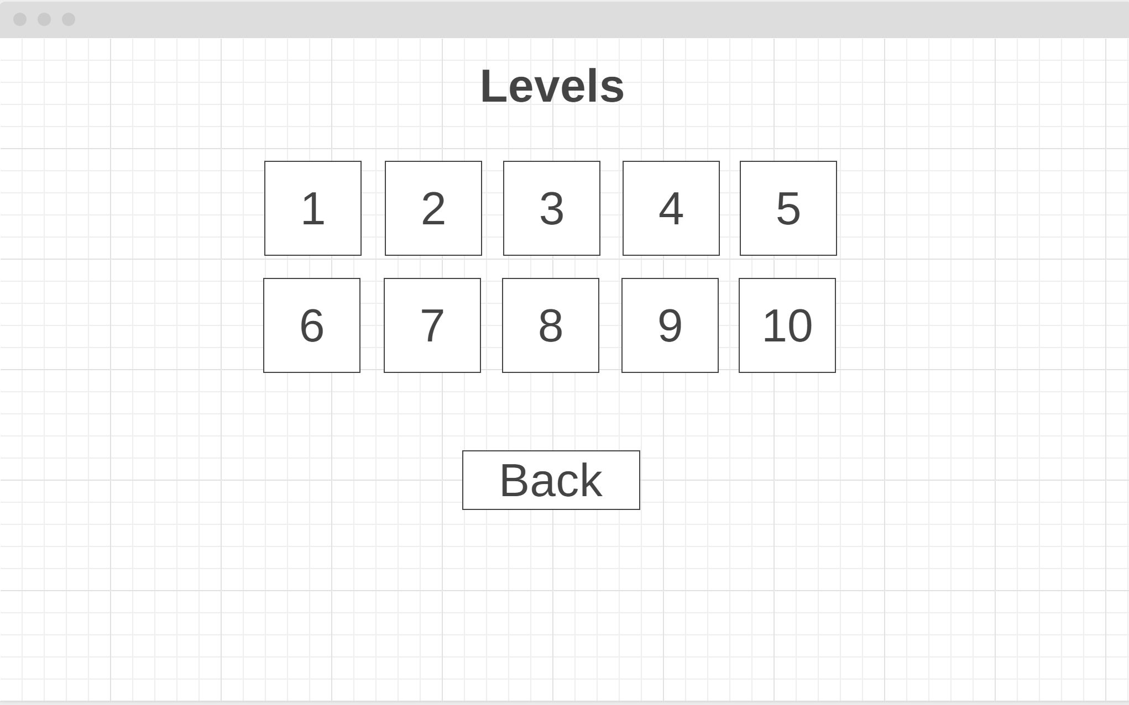

Ein Bild, das Text, Person, Spieler, schlagend enthält.
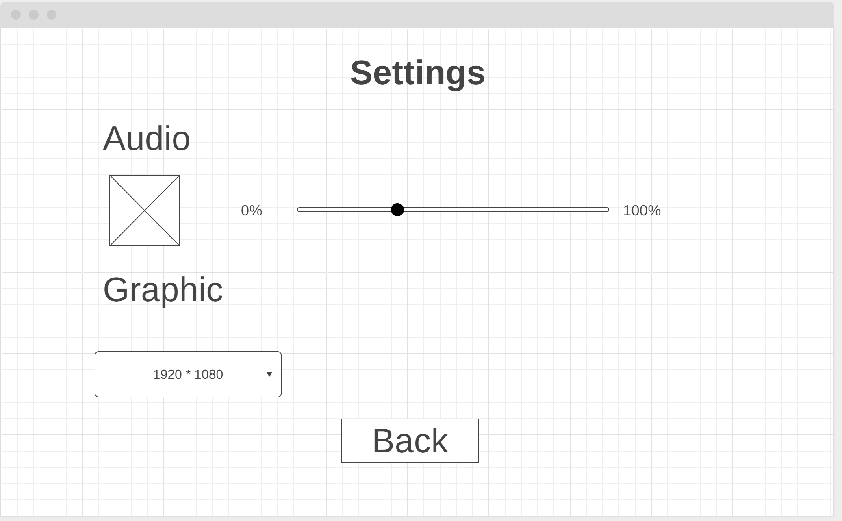

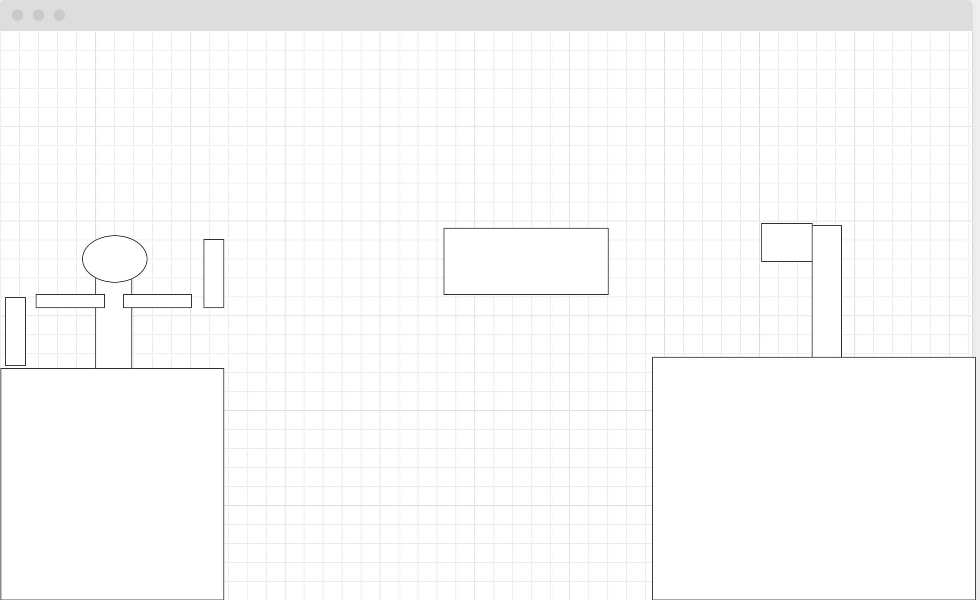

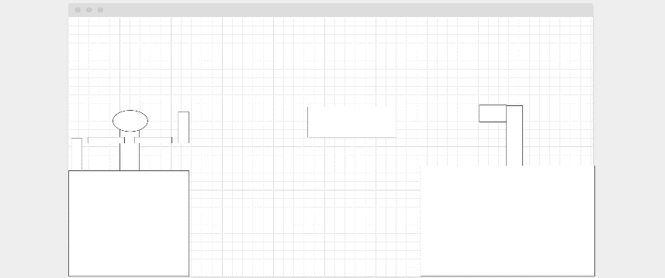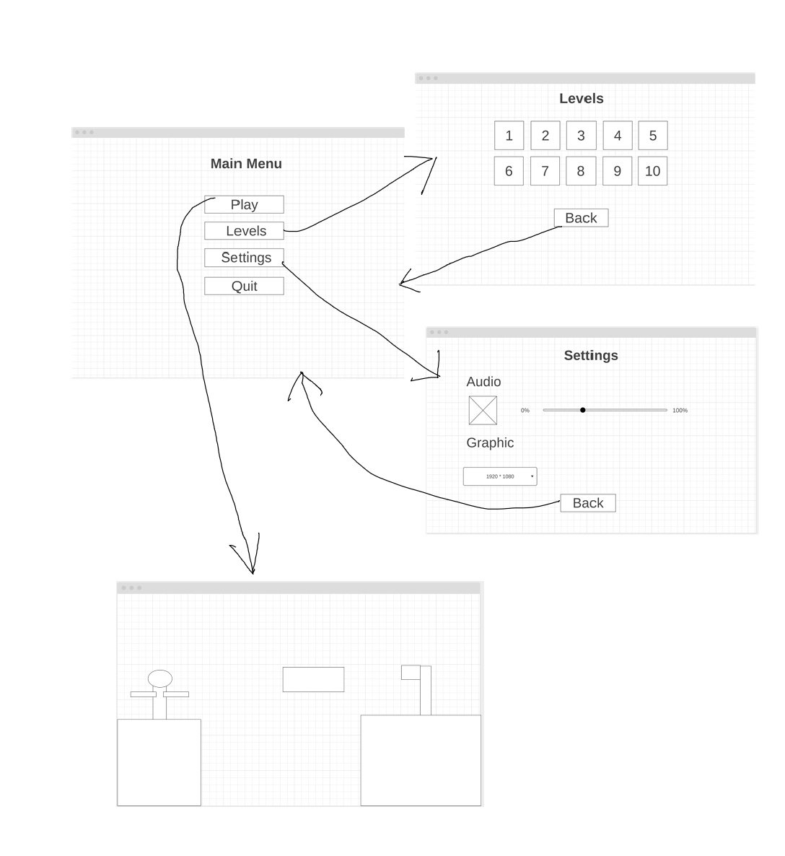

# 

# User manual

## UI navigation

### Main Menu

#### Play

To start the game, press “play”.

#### Levels

To select certain levels, press “levels”.

#### Setting

To change the setting, press “setting”.

#### Quit

To Quit the game, press “Quit”.

### Setting

#### Audio

##### Mute

To mute the game, press the button on the left side

##### Change volume

To change the volume, use the sidebar to select your wished volume intensity.

#### Graphic

To change the resolution, press the dropdown menu and select your intended resolution

#### Back

To go back to the main menu, press “Back”.

### Levels

To select the wished level, click on the a level-box with the wished number.

#### Back

To go back to the main menu, press “Back”.

## Game navigation

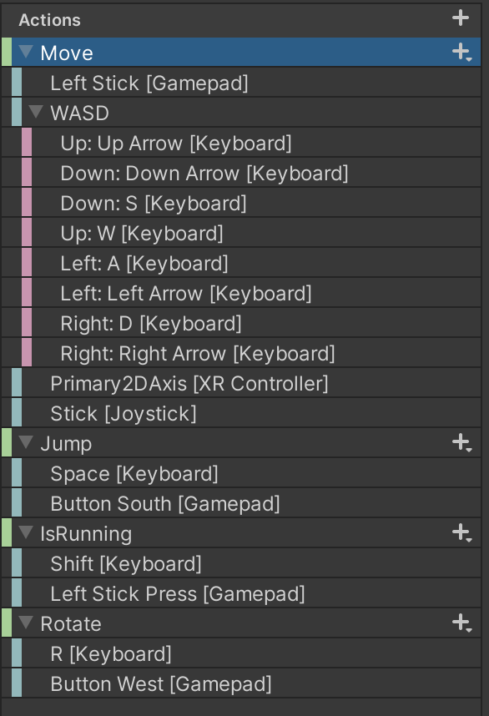

As you can see in the Actions-list. MyPlattformer has full support for Keyboard and controller. This documentation will therefore refer to generalized terms like “jump key” or “up key”.

### Movement

Press any left or right key, to move left or right.  
 Press any up key, while standing on ladders, to climb on ladders.  
 Press any jump key, to jump.  
 Press any key in the “IsRunning” category to enter a sprinting state, which makes you move faster and therefore also jump a greater distance.

### Combat

Press any key in the “Rotate” category to rotate your swords.